

**Project Report: ShopEase - Java-Based E-Commerce Application**

**🔹 Submitted By**

**Name:** Hardik Garg

**SAP:** 500121016  
**Batch:** B7 CSF  
**Session:** 2023-27

**🔹 Acknowledgment**

We, the students of **B.Tech Computer Science and Engineering**, would like to express our heartfelt gratitude to the faculty and staff for their support, guidance, and encouragement throughout the development of this project.

We are also thankful for the resources and learning environment provided by our institution, which enabled us to successfully complete this group project.

**🔹 Abstract**

ShopEase is a Java-based e-commerce desktop application designed using **Java Swing** for the frontend and **MySQL** for the backend. This project enables users to browse products, place orders, and view their order history, while administrators can manage product inventory and view all orders.

The application follows Object-Oriented Programming principles and uses **JDBC** for database connectivity.

**🔹 Table of Contents**

1. Introduction
2. Objectives
3. System Requirements
4. Technologies Used
5. System Design
6. Modules Description
7. Database Schema
8. Screenshots
9. Conclusion
10. Future Enhancements

**🔹 1. Introduction**

ShopEase is an effort to simulate the core functionalities of an online shopping platform. It aims to provide a user-friendly interface where customers can view and purchase products, and admins can manage inventory and order data.

**🔹 2. Objectives**

* Create a fully functional desktop-based e-commerce app
* Implement user registration/login with role-based access
* Enable customers to view, add to cart, and place orders
* Allow admins to add products and manage orders
* Store all data securely in a MySQL database

**🔹 3. System Requirements**

**Software:**

* Java JDK 8
* MySQL Server
* IDE: IntelliJ IDEA
* MySQL Workbench

**Hardware:**

* 16 GB RAM
* 2 GHz Processor or higher
* Windows

**🔹 4. Technologies Used**

| **Component** | **Technology** |
| --- | --- |
| Language | Java |
| UI Framework | Java Swing |
| Database | MySQL |
| Connectivity | JDBC |
| Design Model | MVC (Model-View-Controller) |

**🔹 5. System Design**

**➤ Data Flow Diagram (DFD):**

*Level 0 and Level 1 DFD showing login, product browse, order placement, admin management.*  
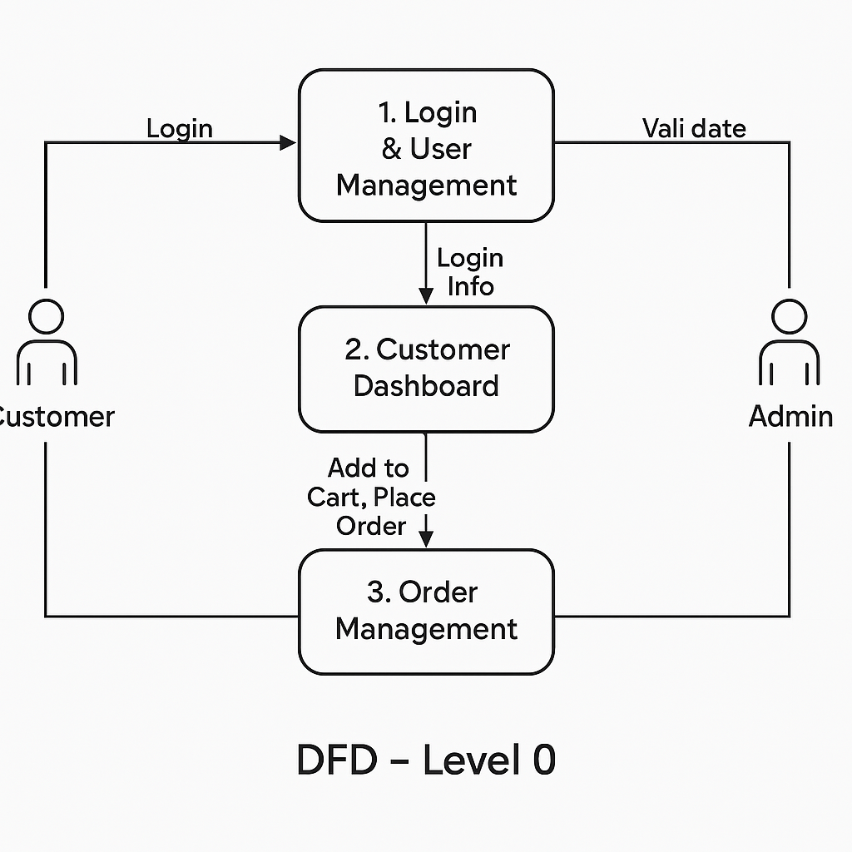

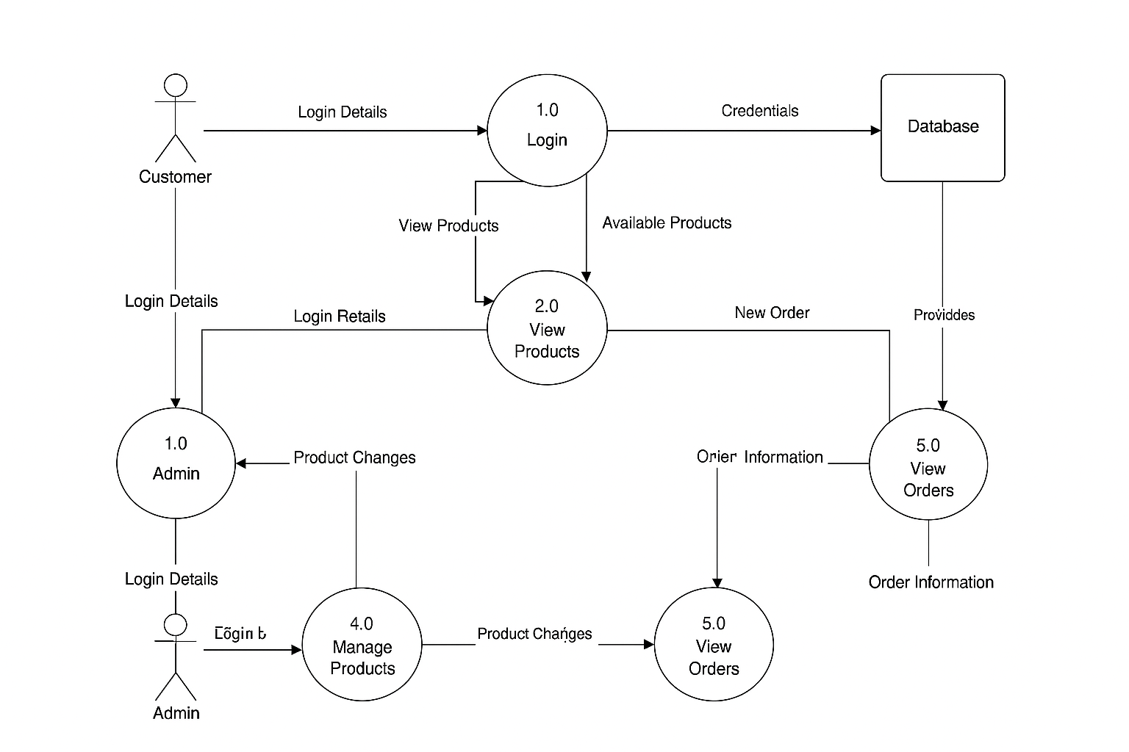

**🔹 6. Modules Description**

**➤ 1. Login & User Management**

Handles user login with role validation (Customer/Admin).

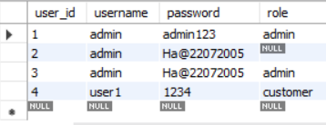

**➤ 2. Customer Dashboard**

Displays available products, allows cart addition, viewing cart, and placing orders.

**➤ 3. Admin Dashboard**

Admin can view and add products to inventory.

**➤ 4. Order Management**

Customers can view order history. Admin can view all placed orders and their details.

**🔹 7. Database Schema**

**➤ Tables:**

* users(user_id, username, password, role)
* products(product_id, name, price, quantity)
* orders(order_id, user_id, total_amount, created_at)
* order_items(order_item_id, order_id, product_id, quantity, price)

*(Include ER Diagram if required by your college)*

**🔹 8. Screenshots**

Attach screenshots of the following:

* Login Screen

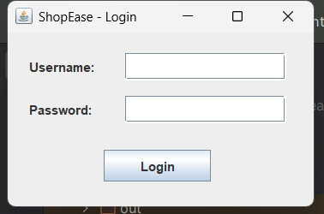

* Customer Dashboard

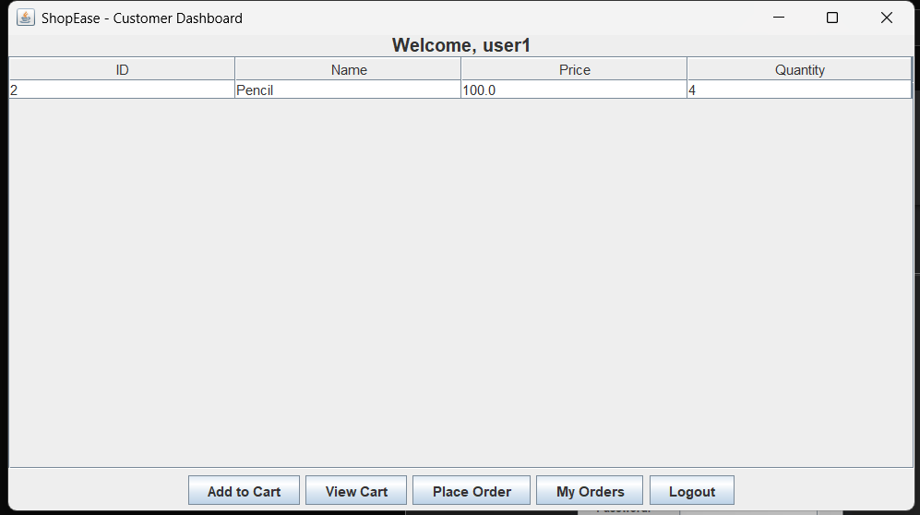

* Cart View

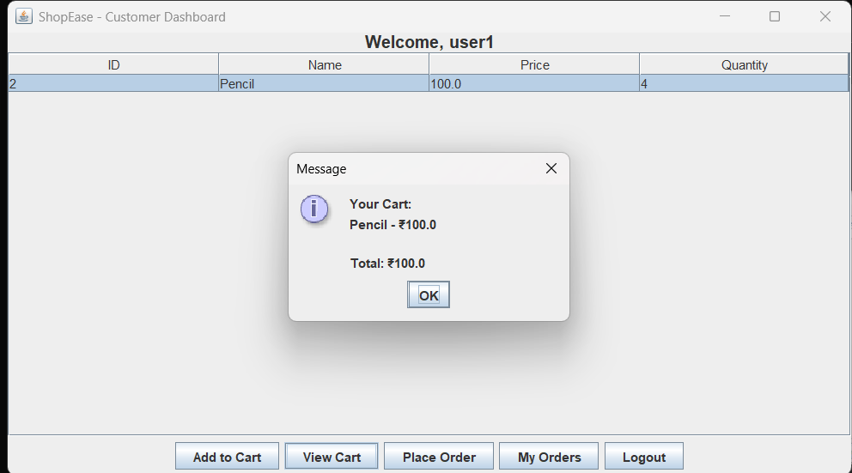

* Order Confirmation

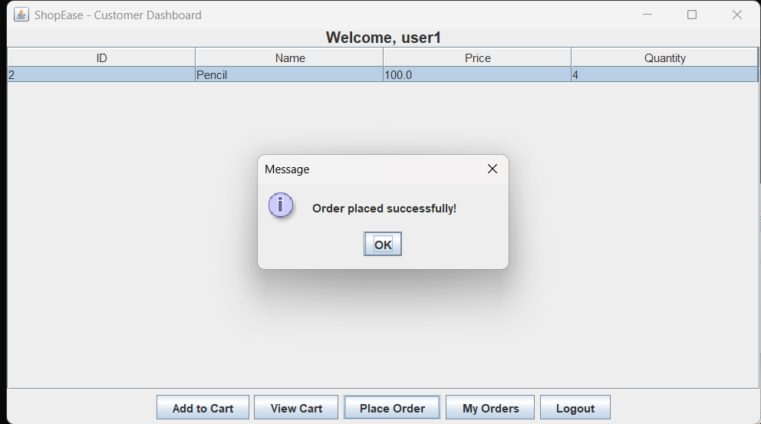

* Admin Dashboard

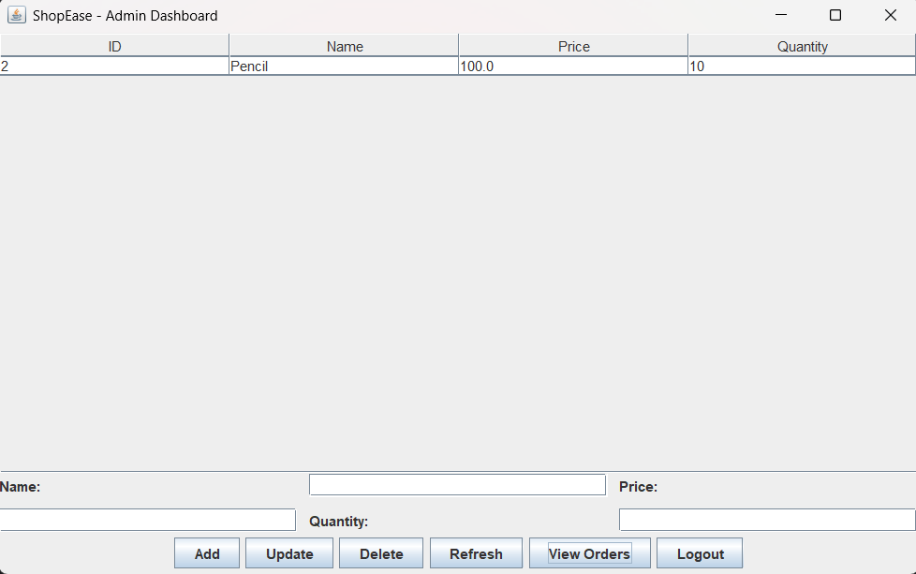

* Admin Order View

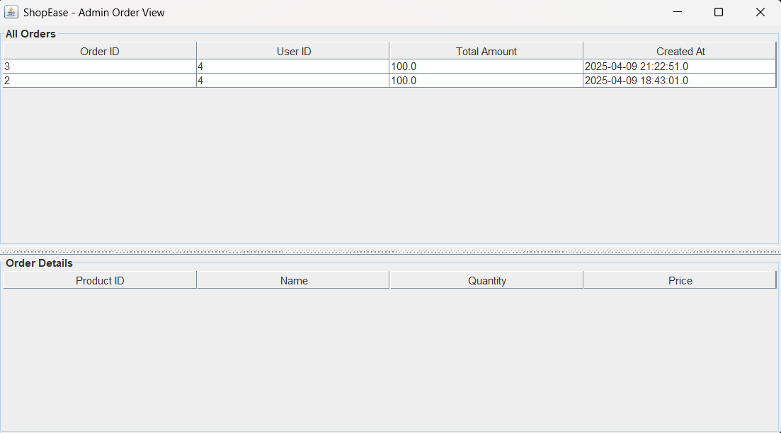

* Customer Order History

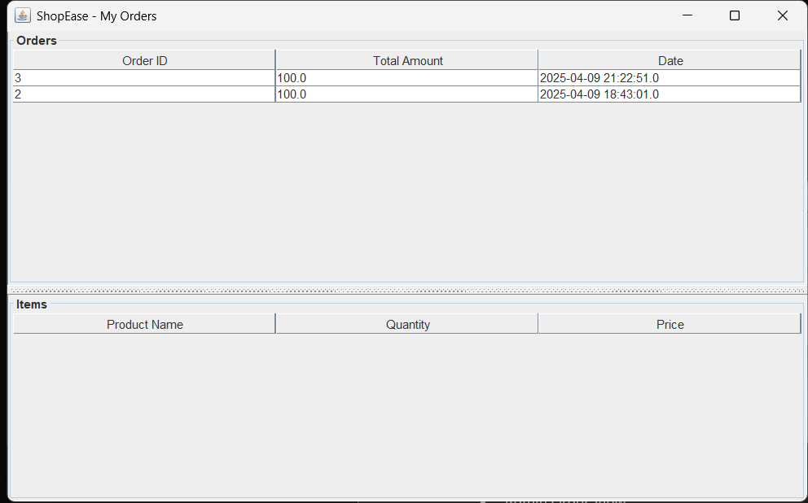

**🔹 9. Conclusion**

This project fulfilled the key objectives of implementing an e-commerce desktop app with basic inventory and order management using Java. It helped strengthen understanding of Swing UI, JDBC, and OOP concepts.

**🔹 10. Future Enhancements**

* Add product image support
* Implement search/filter in products
* Payment gateway simulation
* Enhanced user registration with email/OTP
* Export order history to PDF